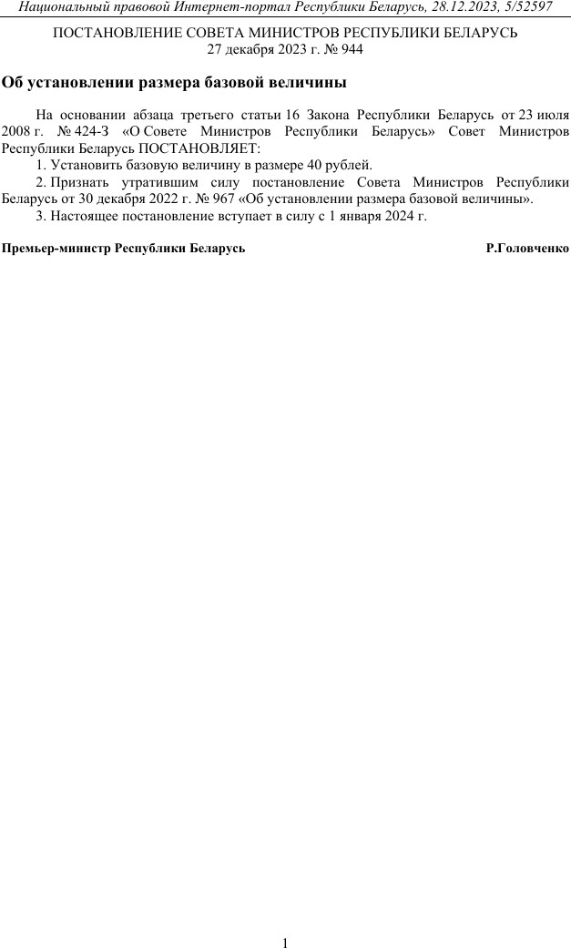

https://docviewer.yandex.by/view/1130000055660693/?*=QTNJv40lZS0%2Fkefu0RKY5WRU0yx7InVybCI6InlhLW1haWw6Ly8xODUyMTA1MzQ… 1/1

